**Analysis of gender inequality in employment life in South Korea**

**Abstract**

As women’s social participation has increased globally, there has been discussion of Gender Equality regarding pay and workplace conditions. However, even the discussion has not been equal everywhere. European countries have tried to reduce the inequality gap in legislation, however the Iranian women still have to seek their rights not to wear the hijab or freedom not to regulate women’s behaviour or restrict their participation in public. Or in some Asian countries, there is a huge gap between gender regarding pay and workplace conditions. As an Asian native who resides in Ireland, I wanted to see and analyse the figures at the workplace, comparing how much the average monthly payslip differs between genders in South Korea. Furthermore, gender pay gaps can show different aspects depending on the age group, so I have also analysed the age group.

**Introduction**

The world has been discussing Gender Equality related to pay and workplace conditions in Europe as well as Asia, as women’s social participation has increased. One European country, Ireland, has many technology companies which tend to be more diverse and open. Irish civil society and government tries to find how best to close the gender pay gap and improve workplace conditions. According to this article, the Citizens’ Assembly recommended that the state should set targets in legislation to reduce the hourly gender pay gap to 9% by 2025 and to 4% by 2030, with a view to eliminating it by 2035.

However, in South Korea, addressing the gender gap is a difficult situation even though the women’s social participation has increased, changing perceptions of marriage, and the growth of Confucian controversial culture etc.

While South Korea has developed fast and has had a miraculous economic development over the past decades, mens’ empowerment has been dominant. As the women’s social participation increased, the dominant male and increasing women’s empowerment inevitably collided.

‘Anti-feminism’ has been a social issue on gender-based violence online and offline, and gender’s interest has been conflicted against changing of social policies between genders. Furthermore, the latest South Korea government led by the ‘anti-feminist’ president Yoon Suk Yeo’s seeks to abolish the gender equality ministry.

58.7 percent of men in their 20s coveted for Yoon, while 58 percent of women in their 20s voted for his opponent (Sumin Lee and Valerie M. Hudson (2022)). 58.7 percent of men in their 20s asserted that the inequality between gender does not exist and would rather say that the new policies at workplace or social results in ‘reverse discrimination’ against men’s rights.

However, according to the survey data from KOWEPS (Korea Welfare Panel Study), which investigates general South Korean life related to welfare, income, living conditions, age etc over past years, it does not seem to be true.

With the survey data, civil society and government analyse the figures and declare government policy and plan to reduce the conflict and make a balanced social life.

**Implementation Process**

Prepared and inserted the survey data from KOWEPS (Korea Welfare Panel Study) in the working directory in Github. As the file is dedicated to SAS file, so installed pyreadstat package in pip install pyreadstat in Mac Terminal and loaded other packages as well. (pandas, numpy, seaborn)

Used pd.read_spss() to load the survey data from KOWEPS and make it copy. As the data survey file is huge, the variables are renamed so it is easy to understand the variable name as per Codebook (Codebook_2020.xlsx) where described the characteristics of the huge data. ‘Monthly wage’ means the average monthly wage for one month and is recorded in units of 10,000 won. (converted euro to 7.16 euro)

As df.dtypes, read variable ‘sex’ and ‘income’ and as df.values_counts(), figure out frequency by category. To read the value of data easily, changed 1 and 2 of variable of ‘sex’ into ‘male’ and ‘female’ and print the results as sns.countplot(). As welfare[‘income].describe(), evaluate the summary of statistics to figure out the characteristics. Create a bar graph using the monthly mean income by gender created so that we can easily understand the analysis results.

To analyse the relation between age and wage, created an ‘age’ variable. Since the survey was conducted in 2020, subtract the year of 2020 and add 1 to get an ‘age’ variable and print the results with df.describe() and sns.histplot().

As gender pay gaps can show different aspects depending on the age group, created table of sex_income and bar gragh, which specifies ageg (age average group) on the x-axis so that the bars are arranged by age group, and specifies sex on the hue so that the color of the bars varies according to gender. Created a line graph of ‘sex_age’ regardless of age group, and specify sex on the hue so that the line color is different for each gender in the graph.

**Results**

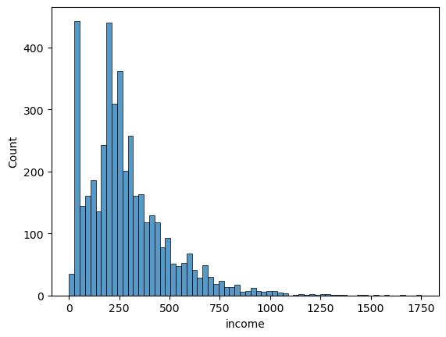

* It has a value of 0 to 17.52 million won. 1,53 ~ 3.70 million won is the most distributed, and the man is 2.83 million won, and the median is 2.43 million won, which is smaller than the average.

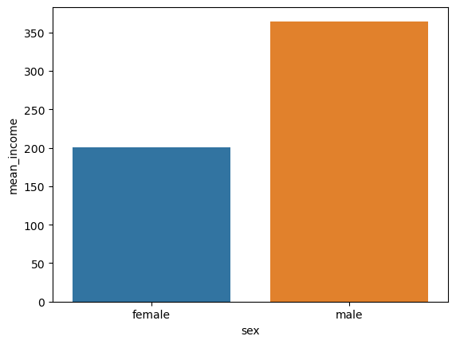

* The average monthly salary differs according to gender. Taking a look at the results, the average monthly salary is 3.64 million won for men and 2.01 million won for women, which is about 1.64 million won more for men than for women.

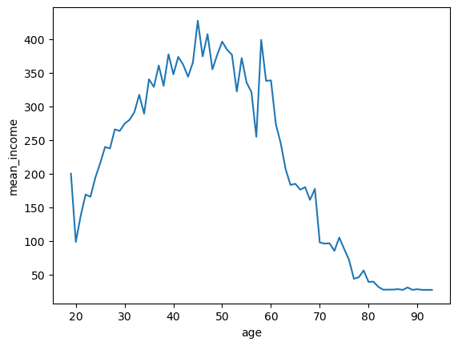

* Analysing the monthly salary according to age, there is a trend of earning about under 2.00 million won in early 20s and continuously increasing thereafter. In their 40s, people receive the most at over 4.00 million won, and dramatically drop down to the late 60s, and receive lower salaries than those in their 20s.

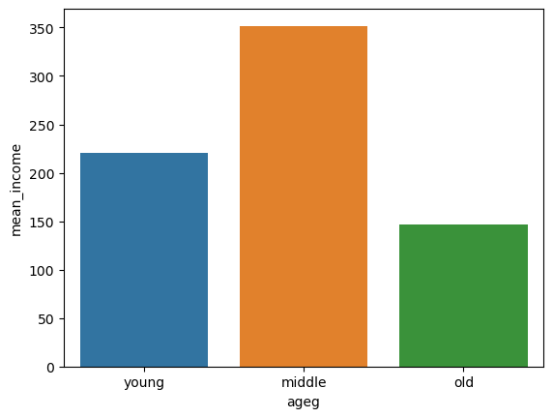

* Created a graph of average monthly salaries by age group to find out how the average monthly salary differs by age group. As a result, the young-age group receives 2.25 million won, the middle-age group receives 3.50 million won, and the old-age group receives 1.50 million won. The middle-age group earns the most and the old-age group earns less than the young-age group does.

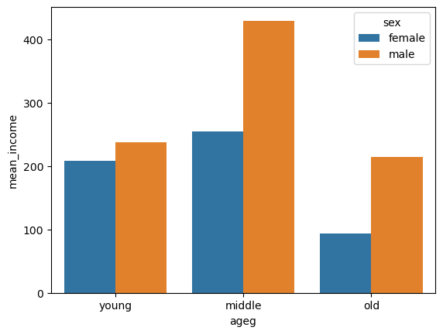

* As per a graph, the aspect of gender wage gap differs by age group. In the young-age group, the wage difference was not large, but in the middle-age group, it widened significantly with men earning more than 1.75 million won and men in the old-age group still receiving more than 1.2 million won.

*In the previous section, it was found that the old-age group earns less than the young-age group. However, according to the result of this, the middle-aged group and the old-aged group receive lower monthly wages than those in the young-aged group and this is only found in women. Men’s salaries are the same for older and younger groups. The fact that middle-aged groups receive higher wages than the young-aged people is mainly found in men, and the difference is not large among women.

**Insights**

* Income inequality is relatively high. Female wage workers earn almost half as much as male wage workers do. Need to analyse further if the job category/industry or job title would differ between genders and need to find out if social protection if a reason why women tend to occupy low-paying, non-regular jobs than men do.

* The average old-age for male earns 2.14 million won and for female earns 9.4 million respectively. Lower earnings and longer life expectancy results in higher poverty and especially older women are at greater risk of poverty. Need to restructure current pension plans or need a plan or policy for the seniors labour market.

* It is expected that the young-aged group earns lower salaries as they just enter the labour market. However, need to find out if they need any financial support as they are frustrated over housing prices, a lack of job opportunities and widening income gap.

* As the middle-aged group earns the most salaries among other groups, they are the most powerful consumption group.

* Male salaries are the same for older and young-aged groups and increase rapidly in the middle-aged group, however, female’s salaries are not much different in the young-aged group and middle-aged group. Need to find practical support for the women who experienced career interruptions due to marriage, pregnancy or child-rearing.

**References**

[Brian O'Donovan](https://www.rte.ie/author/883835-brian-odonovan/) (2022) ‘Committee to discuss gender pay gap in Ireland’, RTE, 6 Oct. Available at: <https://www.rte.ie/news/ireland/2022/1005/1327404-gender-equality-committee/> (6 Oct 2022)

Sumin Lee and Valerie M. Hudson (2022) ‘Rising Backlash Against Gender Equality in South Korea Undermines Stability’, The Diplomat, 28 Oct. Available at: <https://thediplomat.com/2022/10/rising-backlash-against-gender-equality-in-south-korea-undermines-stability/> (28 Oct 2022)

Choe Sang-Hun (2022) ‘‘Meet South Korea’s Swing Voters: Young, Broke and Angry’, The Newyork Times, 8 Mar. Available at: <https://www.nytimes.com/2022/03/08/world/asia/south-korea-young-voters-election.html> (8 Mar 2022)

김영우 (2022), ‘쉽게 배우는 파이썬 데이터 분석' 2nd edition 이지스퍼블리싱